

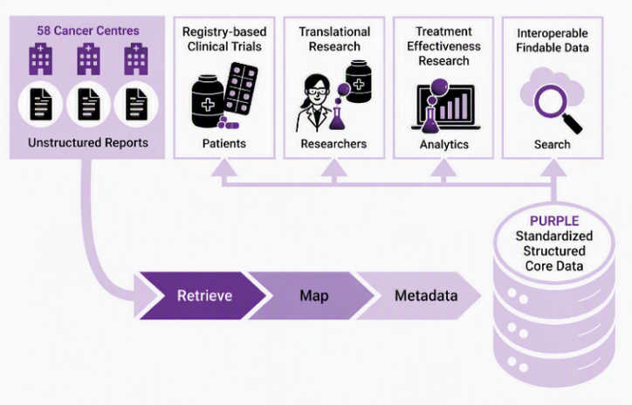

In this edition:
- Welcome to our new registry sites
- PURPLE Registry snapshot
- Abstracts accepted for GI Cancer Trials ASM
- PURPLE Database upgrade
- Publications and Conference presentations
- New project proposals

Welcome to our new PURPLE Registry participating sites:
- ICON Hobart, TAS
- Warringal Private Consulting Rooms, VIC
- Wollongong Hospital & Shoalhaven District Hospital, NSW

PURPLE Registry Snapshot
Working with our partners and collaborators, here’s a snapshot of what’s been achieved:

7103  Patients with pancreatic cancer data recorded in the PURPLE Registry | 58  Participating sites contributing data to PURPLE | 86  Research studies that used PURPLE Registry data | 79  Presentations, posters & publications using PURPLE Registry data

GI Cancer Trials ASM 2026 - Abstracts accepted
We’re pleased to announce that four PURPLE abstracts have been accepted for presentation at the GI Cancer Trials Annual Scientific Meeting (ASM) in Hobart this November.

- Real-world patterns of second-line systemic therapy and outcomes in metastatic pancreatic ductal adenocarcinoma: an analysis of the PURPLE registry
- Improving collaboration in Pancreatic Cancer Clinical Trials: The PURPLE Registry Trials Portal
- Outcomes of locally advanced pancreatic cancer following neoadjuvant therapy in the Asia-pacific region: a multi-national, multi-institutional retrospective analysis
- Analysing Survival Outcomes in Advanced Pancreatic Cancer: Benefit of Second and Later Line Therapy – Real World Outcomes from the Australasian PURPLE Pancreatic Cancer Registry

If you're attending the ASM, keep an eye out for the PURPLE logo during the Poster Walkaround Sessions and stop by to chat with our investigators about the latest findings from the registry.

PURPLE Database Upgrade
 | PURPLE to support biliary cancer data collection  The PURPLE registry database has been upgraded to support future growth and innovation. These enhancements include a new biliary cancer module.  For sites that have received local RGO approval for the Protocol V5 amendment, which includes the addition of biliary cancer data collection, the new biliary module will be available for use later this year.  Additionally, for sites interested in capturing Pancreatic Enzyme Replacement Therapy (PERT) data, a new REDCap module has been developed. This module will support much-needed research into the use and outcomes of PERT for patients living with pancreatic cancer.
Research publications and conference presentations
We’re pleased to share that the following papers utilizing PURPLE registry data have been presented and published. Click on the links to read the full article.

- Timeliness of Care and Treatment Patterns for Pancreatic Cancer in Victoria, Australia: Comparison with Optimal Care Pathways Targets – S Banks, B Lee & N Ayres, et al (ANZJS)
- Systematic Review and Meta-Analysis of Current and Novel Approaches in the Management of Borderline Resectable and Locally Advanced Pancreatic Cancer – K Le & O Yoshino, et al (Cancers)
- Predicting recurrence patterns and outcomes following resection of pancreatic ductal adenocarcinoma: a contemporary real-world data cohort study – E Mane & B Lee, et al (AMS)
- Poor-prognosis cancers: from resignation to revolution – J Iovanna, et al (JOGSOP)
- Skeletal muscle & visceral fat density are predictive imaging biomarkers for overall survival in patients with pancreatic adenocarcinoma: A retrospective multicenter analysis – M Theis, W Hong & H Ko, et al (SurgOnc)
- Decision support tools for pancreatic cancer detection: external validation in Australian primary care - a retrospective cohort study – S Schrader, et al (BJGP)
- Patterns of care and clinical outcomes of elderly pancreatic cancer patients in the PURPLE Translational Registry – Z Hameed & A Jain, et al. AGITG Annual Scientific Meeting 2025.
- Real-world outcomes in early stage resected pancreatic cancer. Can we do better? A PURPLE Registry data analysis – T Ouyang & W. Hong, et al. AGITG Annual Scientific Meeting 2025.

Selection of upcoming new projects
- Retrospective Descriptive Analysis of Pancreatic Enzyme Replacement Therapy (PERT) Patterns and Survival Outcomes in Locally Advanced Unresectable and Metastatic Pancreatic Adenocarcinoma with Exocrine Pancreatic Insufficiency in the Australian Capital Territory.
- Optimizing Adjuvant Chemotherapy in Resected Pancreatic Cancer: Impact of Regimen Selection, Timing of Initiation, and Completion Rates on Survival Outcomes.
- Validation of an automated genomic data extraction tool against manual human data entry in oncology registries.
- Registry-based external control as substitute for phase 3 randomised control arm.
- A Comprehensive Analysis of Claudin 18.2 Expression in Patients with pancreatic ductal adenocarcinoma
- CT Body Composition and Chemotherapy Outcomes - whether baseline body composition predicts PFS and OS across treatment groups.

If you have a particular interest in an aspect of pancreatic cancer research and wish to discuss an idea or research study proposal that could use PURPLE Registry data, please get in touch with us at: purplepancreas@wehi.edu.au

The PURPLE team extends our thanks to all existing and on-boarding sites for being part of this collaborative network.

If your hospital or cancer centre is interested in joining the PURPLE Registry as a participating site, please

contact us: purplepancreas@wehi.edu.au





